Efficient treatment of trigger points with ozone
The use of ozone in the hypertonic musculature

Dr. med. A. Balkanyi
22.10.04, Bad Kreuznach

Introduction

Trigger points are one of the most frequent causes musculoskeletal pains. However, in the last few years has appropriate attention been given to this trigger points, except for the earlier work by a few pioneers in this field.

Myofascial pain syndromes (MPS) as percentage of all forms of chronic pain affecting the locomotor system
Skootsky 1989 30%
Fishbain 1989 85%
Fricton 1990 55%
Gervin 1995 93%

Since the practical significance of trigger points was discovered, there has been a veritable boom both in basic research and in the therapeutic possibilities. As jet, the diagnosis myofascial trigger point can be made only clinically, but not based on laboratory-chemical or radiological findings.

Tissular pO₂ measurements of the chronically hypertonic M. erector spinae in 20 patients, compared with 10 healthy controls were carried out by Brückle.
Interestingly, the pO₂ levels in the hypertonic musculature rose proportionately to the degree of hypertonia musculature. The mean tissular pO₂ level was 38.5 mmHg, which was 9 mmHg more than that of the healthy controls, with a standardised mean reference value of 29.5 mmHg.
.
Various authors have found significantly low levels of adenophosphate in the
hypertonic musculature, with high pO₂ level. It can therefore be resumed that the raised pO₂ levels result from deficient oxygen utilisation due to an inadequate supply of high-energy phosphates.

Myogeloses are olive- to plum-sized areas of hardening in the muscles.

The tissular pO2 measurements showed raised pO2 levels at the margin of the myogeloses, which towards the centre fell to hypoxic levels of under 5 mmHg∗.

pO₂ ₌ 38, 5 mm Hg
chronically
hypertonic muscle

pO₂ = 5 mm Hg

Gradual lowering of the pO₂ level from the margin towards the centre of the myogelosis.

The explanation for this is the occlusion of the microcirculation at the margin of the myogeloses. This is possibly triggered by compression due to spasm of muscle fibres surrounding the blood vessels within the muscle and the oedema in this area. Compression of the microcirculation causes local hypoxia, with subsequent acidosis due to the formation of lactate. The lowering of the pH value leads to loss of flexibility of the erythrocytes and occlusion of the already stenosed vessels. Also vasoneuroactive substances histamine, bradykinin, substance P (SP) and calcitonin gene-related peptides (CGRP) are released. As a result, an oedema is formed which further compresses the vessels and exacerbates the hypoxia. The oxygen can then pass from the margin into the interior of the myogelosis only by diffusion, because of which there is a gradual lowering of the pO2 level towards the centre.

The deficiency of high-energy phosphates causes a disturbance of the function of the calcium-ion-pump both in the chronically hypertonic musculature and in the myogelosis. There is a partly exhaustive autonomous contraction which in turn leads to a further reduktion of the alkali reserve, with further disturbance of the muscle metabolism.

As already mentioned, mediators of inflammation and vasoactive substances are formed, which sensitises the nociceptors in the sense of hyperalgesia. On the other hand, the inflammatory metabolism leads to the creation of oxygen radicals, the formation of which is promoted by the raised pO₂ level in the hypertonic muscle. The excess of oxygen radicals causes a dekompensation of the enzymatic scavenger system. The obvious assumption is that the free radicals can lead to further destruction of muscle tissue and nerve tissue – with an increase in the hyperalgesia.

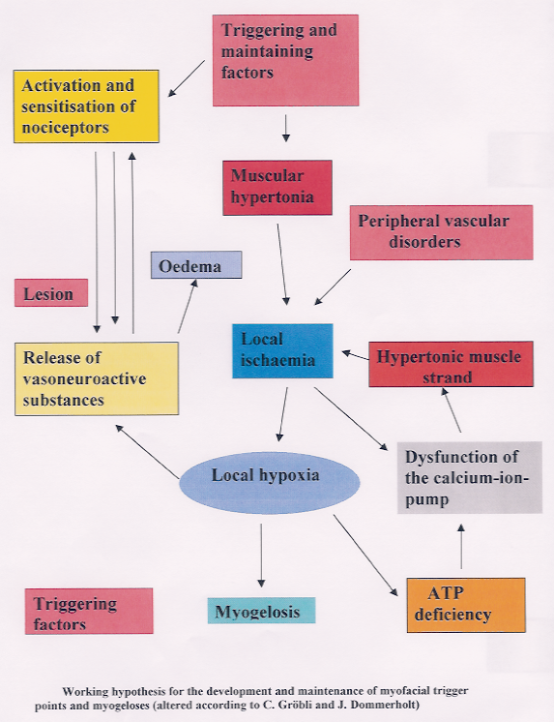

The following factors, among others, are important for the physiological development of muscular contraction:

- A supply of oxygen sufficient for an aerobic contraction.
- An amount of glycogen, which as an energy carrier with an adequate supply of oxygen provides the necessary energy.
- High-energy phosphates, which facilitate utilisation of the oxygen.
- Adequate amount and composition of electrolytes that are important for the muscular contraction.
- Elimination of iron, folic acid and vitamins B₁, B₆, B1₂, c deficiency, hypothyroidism and hypoglycaemia.
- Elimination of any excess of free radicals.

Ozone acts on the metabolism in the following ways, among others:

- Amounts of ozone stimulate the formation of glutathione peroxidase, which activates glycolysis.
- Glycolysis leads to the formation of 2, 3-DPG and ATP.
- 2, 3-DPG facilitates the release of oxygen to the tissue.
- Low ozone concentration activate the enzymatic scavenger system, mainly the glutathione peroxidase, catalase and superoxide dismutase. They break down the oxygen radicals that are formed by degenerative and inflammatory processes.

This mode of action of ozone aims at the above-mentioned pathological processes in the hypertonic musculature and in the myogeloses, and forms the therapeutic basis for extensive normalisation of the pathological states in the hypertonic musculature and the myogeloses.

Method used

From the point of view of clinical practice, the following main criteria, in decreasing order of specificity, may be used for the diagnosis of trigger points:

Main clinical criteria for the diagnosis of myofascial trigger
points, in decreasing order of specificity

Local pain on pressure within a hard, hypertonic muscle strand
A hard, hypertonic muscle strand, palpable from its origin to its point of insertion

Local twitch response with twitching of the muscle fibres within a taut band as a reaction of mechanical stimulation of the MTrP

Radiating of a characteristic referred pain as a reaction of mechanical simulation

Renewed recognition of the pain by the patient

The frequency of the treatment is determined by the number and the mass of the affected muscles. It can be between once and five times a week.

Two types of injections can be used: Precisely targeted injections into the trigger points respectively myogeloses and multiple or fan-shaped infiltrations into large muscles.
Whenever possible, fine calibre cannulas should be used corresponded to the intended depth of the injection.
At first is lidocaine or procaine injected. The amount of lidocaine ½ percentage: 1 to 20 cc and lidocaine 1%: 1 to 10 cc. Procaine 1%: 1 to 10 cc. After injection of local anaesthetic, an ozone/oxygen mixture will be injected through the same cannula. Depending on the size of the muscle and the mode of application (injection in the hypertonic mass or at a given point), the amount of ozone injected should be 1 to 10 or eve 20 cc of a 15 to 20 µg/ml solution per muscle. The ozone should be insufflated slowly in order to avoid pain as far as possible.

During the injection the muscle should be massaged in order to obtain better distribution of the ozone.

Whenever possible, passive stretching of the shortened muscles should be carried out at the end of the tonanalgesic therapy and the patient should be given appropriate instructions for daily active muscle stretching exercises. Muscle-stabilizing exercises should also be performed during and after the end of the treatment.

Reactive muscle pain may happen, as an occasional, insignificant side effect.
It is interpreted as being a result of insufficient distribution of the ozone/oxygen mixture in the muscle or due to the injection of a relatively too large amount of ozone. The results are some times markedly better than after painless injections. May be because some of the trigger points have been destroyed.

 This pO2 value corresponds to the oxygen tension observed in peripheral occlusive arterial disease POAD), in the painful phase.

