Efficiency of Tazobactam/Piperacillin in lethal peritonitis is enhanced after

pre-conditioning of rats with O₃/O₂-pneumoperitoneum.

M. Bette¹, R.M. Nüsing², R. Mutters³, Z.B. Zamora⁴, S. Menendez⁴, S. Schulz⁵

¹Institute of Anatomy and Cell Biology, ²Department of Pediatrics and ³Institute of Medical Microbiology, Philipps-University of Marburg, Germany; ⁴Ozone Research Institute, National Centre for Scientific Research, Havana, Cuba; ⁵Veterinary Services and Laboratory Animal Medicine, Philipps-University of Marburg, Germany

Address of correspondence: Dr. med. vet. Siegfried Schulz, Philipps-University of Marburg, Veterinary Surgeon, Deutschhausstr. 2, 35033 Marburg, Germany
fax: +49 (0)6421-286-2214
email: schulz@staff.uni-marburg.de

Short title: Tazobactam/Piperacillin in lethal peritonitis

Keywords: antibiotic therapy, cytokines, mortality, oxidative stress, sepsis

Abstract
Insufflation of ozonized oxygen into the peritoneum (O₂/O₃-pneumoperitoneum, (O₂/O₃-PP)) of rats reduced the lethality of peritonitis. We evaluated the prophylactic effect of O₂/O₃-PP combined with Tazobactam/Piperacillin (TZP) in poly-microbial lethal peritonitis. Wistar rats were conditioned by daily repeated insufflation of ozone for five days and haematological parameters were determined. Sepsis was induced by i.p. injection of caecal material derived from donor rats. Simultaneously, TZP was applied at a single dosage of 65 mg/kg or at two dosage schedules of 65 mg/kg each at an interval of 1 h. The conditioning effect of O₂/O₃-PP on the number of blood cells was measured before inoculation of bacteria. The mRNA levels of pro-inflammatory cytokine IL-lß and TNFα were determined at 4 h post-infection in spleen and liver by semi-quantitative in situ hybridisation analysis. Pre-conditioning of rats by O₂/O₃-PP enhanced the number of blood leukocytes and granulocytes and increased the survival rate of septic rats up to 33%. The combination of O₂/O₃-PP and TZP further enhanced the survival rate up to 93%. This effect was accompanied by a reduced amount of IL-1ß- and TNFα mRNA in spleen and liver. In contrast, in non-infected animals the combination of O₂/O₃-PP and TZP enhanced IL-1ß- and TNFα mRNA in the spleen and IL-1ß mRNA in liver when compared to TZP- and sham treated controls. The pre-conditioning effect of O₃/O₂-PP seems to support the biological effectiveness of TZP by altering the immune status before and during the onset of sepsis. The combined therapy could be a simple, pre-operative intervention for abdominal surgery to reduce post-operative morbidity and mortality.

Introduction
Modern antibiotics are without any doubt the most important cornerstones in the treatment of mild and severe infectious diseases. But, when given in high dosages in severe clinical situations and when long-term application is necessary, adverse effects and antibacterial resistances may develop with increased antibiotic consumption (1-3).
Tazocin is an injectable antibiotic mixture consisting of the semi-synthetic antibiotic piperacillin-sodium (PIP) and the beta-lactamase inhibitor tazobactam-sodium (TZB). It is generally considered safe, and only in very rare cases can high doses cause pseudomembranous colitis, significant thrombocytopenia, leukocytopenia, bone marrow suppression (4-9), or haemolytic anemia (10). One clinical use of TZP is the treatment of intra-abdominal infections (11, 12). However, TZP could interact with other drugs given before or simultaneously. This interference could be beneficial or detrimental in the course of infection and inflammation. The clearance of tazobactam can be prolonged by substances such as probenecid (13) and thus might increase adverse effects.
In the rat model of lethal sepsis, positive as well as negative effects of antibiotics with distinct influence on the outcome of a severe abdominal infection have been shown (14, 15). In the search for new experimental strategies, the hyperbaric oxygen therapy (HBO) was found to be a beneficial adjuvant therapy for different infectious diseases (16, 17). This oxygen therapy by inhalation was also shown to be beneficial in peritonitis, endotoxic shock or multiple organ failure (18, 19) and it was found to prevent bacterial translocation after mechanical obstruction or thermal injury (20). In a lethal peritonitis study in rats we have recently shown that an oxidative pre-conditioning use as a new therapeutic approach (O₃/O₂-pneumoperitoneum, O₃/O₂-PP) enhanced the survival rate up to 33% (21). Recently, ozone has been described as an endogenously produced gas (22) suggesting a physiological role of this gas in vivo. On the basis of the oxidant properties of ozone and based on the possibility that lipid oxidation products (23, 24) may exert anti-inflammatory properties which are potent enough to protect animals from LPS induced tissue damage (25), we postulate that ozone may attenuate the susceptibility to septic shock.
The aim of our study was to analyse whether the pre-conditioning with ozonized oxygen has any influence on the survival /mortality of septic rats when combined with an intramuscular (i.m.) injection of TZP given in a bolus-like low concentration comparable to that used in children (26). To comprehend a possible biological mechanism of TZP in combination with insufflation of ozonized oxygen into the peritoneum, we measured the number of blood cells before and after O₃/O₂-PP. Additionally, the expression of pro-inflammatory cytokines (IL-1ß and TNFα) in spleen and liver early (4 h) after induction of a lethal bacteraemia were analyzed.

Material and Methods
Animals
For mortality analysis adult male Wistar rats (180-200g) were obtained from the National Centre for Laboratory Animals Production (Havana, Cuba). The Health Certificate No. RG. CC. O2.95 showed that the animals were free from Salmonellae specificae, Streptobacillus moniliformis, Streptococcus-ß-pyogenes, Bordetella bronchiseptica, Corynaebacterium kutscheri, Citrobacter freundii, Streptococcus pneumoniae and Shigella specificae. For hematological, microbiological and histological analysis, healthy (as given by FELASA recommendation) adult male Wistar rats (209–215g) were purchased from Harlan (Borchen, Germany). All animals were kept in rooms with a standardized air conditioning 20-22°C, 50–57% humidity and a 12 h artificial day/night rhythm. The rats had free access to standard diet food pellets delivered either by The Division de Alimentation y Nutricon CENPALAB (No. FF.CC.01.95; Havana, Cuba) or by Altromin (No. 1320; Lage, Germany). Water was available ad libitum. Survival analysis performed in Cuba was in accordance with the European Union Guidelines for animal experimentation and was approved by the Institutional Animal Care Committees (ARCA No. 015). Haematological and histological experiments performed in Germany were in accordance to the guidelines of FELASA and were approved by the RP Giessen (Az: 17a-19c20-15(1)) according to the Germany Animal Protection Law.

Experimental design and treatment of rats
For mortality analysis ozonized oxygen was generated by an Ozomed machine (OZOMED, Ozone Research Centre, Havana, Cuba). In the case of animal experiments, which were performed for the microbiological and histological analysis an Ozonosan gas processor (PTN 60, Dr. Hänsler GmbH, Germany) was used. Ozone concentrations were monitored by an Ozonosan photometer (Dr. Hänsler GmbH Iffezheim, Germany). The gas mixture containing 5 % volume ozone and 95 % medical oxygen (O₃/O₂) was immediately insufflated with a standardized volume of 80 ml/kg rat by injection (needle size: 21 g) into the right lower abdomen of the rats. The O₃/O₂ treatment was repeated daily for 5 days.
Fresh faecal material was obtained from the caecum of male Wistar rats. The mean spectrum of caecal organisms was (given in Colony forming units (CFU)/g): E. coli (1 x10² - 1x10⁷), Bacteroides distasonis (0.5x10⁷ - 1x10⁸), Prevotella oralis (0.5 x 10⁷ - 1 x 10⁸), Proteus mirabilis (1x10⁵ - 1x10⁷) and Enterococcus faecalis (1x10⁶ - 1x10⁷) with highest frequencies and Streptococcus sp. (1x10⁷), Staphylococcus aureus (1x10⁴), Bacillus sp. (1x 10¹) and Micrococcus (3x10¹) with lesser frequency. The infection with caecal material started 24 h after the last gas insufflation. Simultaneously to the infection, TZP in a combination of TZP and PIP in a fixed ration of 1:8 dissolved in saline (Wyeth, Muenster, Germany), was injected i.m. at an empirical dosage of 65 mg/kg body weight (b.w.). This dose is low in comparison to the recommended high doses in humans based on a body-surface-area basis (mg/m²) (27). A second group received an additional injection of 65 mg/kg at 1 h after infection resulting in a total amount of TZP of 130 mg/kg b.w.. A sham group (n =15) was pre-treated with daily injections of 80 ml/kg filtered room air or pure oxygen of 80 ml/kg b.w., infected with caecal material and received an equal amount of saline instead of the antibiotic. Animals (n = 12) which were pre-treated with daily injections of the O₃/O₂ gas mixture but received no injection of caecal material were used as controls for pure ozone effects. Non-treated animals (n = 20) which received no injection of any gas, no infection with caecal material, and no saline injection were used as the basal control. For histological analysis 4 h after infection, rats were first narcotised with forene by inhalation followed by a lethal intracardial injection of T61 (Hoechst Roussel Vet., Germany). For mortality analysis rats were observed for five days.

Haematological Parameters
To measure basic haematology and differential blood counts we obtained 50 μl EDTA-blood O₂/O₃ for five days by puncturing the retro-orbital sinus under forene anaesthesia. For the haematological investigations we used an autoanalyzer (Vet abcTM Animal Blood Counter, ABX Diagnostics, Göttingen, Germany), which has been carefully validated for the analysis of rat blood. For basic haematology we determined the haematocrit (HCT), haemoglobin (HGB), mean corpuscular volume (MCV), mean corpuscular haemoglobin (MCV), and mean corpuscular haemoglobin concentration (MCHC), For differential blood count the number of red blood cells (RBC) and white blood cells (WBC), which were further differentiated into lymphocytes, monocytes granulocytes, and platelets, were measured. Data were expressed as mean values ± S.E.M.. Significant differences were determined using the student t test followed by ANOVA (n = 6).

In situ hybridisation
In-situ hybridisation was performed for ³⁵S-labeled IL-1ß and TNFα mRNA templates on 14 µm thick cryostat sections as previously described in detail (21). In short, pGEM-T vectors (Promega, Mannheim, Germany) containing rat specific cDNA fragments for IL-1ß or TNFα were linearized with the appropriate restriction enzymes and ³⁵S-labeled sense and antisense ribonucleotide probes were generated by in vitro transcription using SP6 or T7 polymerases (Boehringer Mannheim, Germany) as appropriate in the presence of ³⁵S-UTP (Amersham Life Science, Germany). All labeled cRNA’s were purified over Micro Bio-Spin® Chromatography columns (Bio Rad, Germany) and diluted in hybridization-buffer (100mM Tris pH 7.5, 600mM NaCl, 1mM EDTA, 0.5 mg/ml t-RNA, 0.1 mg/ml sonicated salmon sperm DNA, 1x Denhardt’s, 10% dextrane sulfate, 50% formamide) to 50.000 cpm/µl. Autoradiograms were taken by exposing the sections to an autoradiography film (Hyperfilm-ßmax, Amersham, Dreieich, Germany) for 1-3 days. For control of the specificity of the in situ hybridization signals sense ³⁵S-labeled cRNAs for IL-1ß and TNFα were used and showed no signals in any of the experimental groups. The in situ hybridization experiments were performed twice. For semi-quantitative image analysis the-X-ray films were digitized and the mean relative optical density (ROD) was measured by using the MCID image analysis system. Data were expressed as mean values ± S.E.M. from s = 12 measurements per group. Significant differences were determined using the student t test followed by ANOVA.

Results
Effect of TZP in combination with O₂/O₃-PP pre-conditioning on the survival rates of septic rats
To test if a low dose of TZP used in a single (65 mg/kg) or repeated (2 x 65 mg/kg) application can protect adult Wistar rats from a lethal peritonitis, the survival rate was determined for an observation period of five days. A single dose of TZP given at the same time point when sepsis was initiated did not influence the mortality rate and mean time of death within the first 24 h (Fig. 1A) whereas two doses of TZP prolonged the mean time of death up to 48 h. Nevertheless, all animals died within 72 h (Fig. 1A). To analyse if the weak effect of the low dose of TZP on the survival time can be enhanced by a prevention therapy with ozonized oxygen which was found to enhance survival up to 33% when given alone (Fig. 1A), we applied TZP in animals which were pre-conditioned by the repeated insufflation of ozonized oxygen into the peritoneum (O₂/O₃-PP). We found a dramatic effect of TZP in the O₂/O₃-PP pre-conditioned experimental group. The survival rate was enhanced by TZP up to 78% when given as a single dose and was further enhanced up to 93% when two doses of TZP were given (Fig. 1B). Body weight analysis of the surviving animals showed that O₂/O₃-PP pre-conditioned and TZP-treated rats had a slightly decreased body weight -3.6 % ± 3.9 % after the five days of post-infection. In contrast, non-infected control rats showed a normal weight gain development of +11.7 % ± 1.6 %. The specific effect of ozonized oxygen in combination with TZP (130 mg/kg) was shown in comparison to the effects of pure oxygen and atmospheric air (Fig. 1B). In TZP-treated animals, which received a pre-conditioning with atmospheric air all animals died within 24 h of post-infection. In TZP-treated animals pre-conditioned with pure oxygen, the time of death was delayed but all animals died within 120 h after initiation of sepsis, too.

Influence of O₂/O₃-PP pre-conditioning on haematological parameters
Obviously, O₂/O₃-PP pre-conditioning protects rats from a lethal outcome of infection with poly-microbial caecal material. To prove the hypothesis that O₂/O₃-PP pre-conditioning mediates its beneficial effect by altering the immune status, we measured various haematological parameters. We found a significant increase in the number of white blood cells (WBC) after a repetitive pre-conditioning of rats by daily application of O₃/O₂ (Fig. 2 B). Analysis of the cellular types of the WBC revealed lymphocytes (Fig. 2 C) and granulocytes (Fig. 2 D) as the most likely cell types which contribute to these changes rather than monocytes. This indicates a pre-conditioning effect of the oxidative gas mixture on both the innate immune system represented by granulocytes and on the adaptive immune system represented by lymphocytes. The haematocrit (HCT), haemoglobin (HGB), mean corpuscular volume (MCV), mean corpuscular haemoglobin (MCV), and mean corpuscular haemoglobin concentration (MCHC) were unaffected by the oxidative pre-conditioning (data not shown).

Analysis of cytokine mRNA expression levels in O₂/O₃-PP pre-conditioned TZP treated rats
We further that the pronounced effect on the number of lymphocytes and granulocytes is based on changes in the bacterial-induced expression of pro-inflammatory cytokines. For this, we measured the mRNA expression of IL-1ß and TNFα mRNA in the spleen and liver at an early time point (4 h) after inoculation of the caecal material. Semi-quantitative image analysis of X-ray autoradiograms derived from in situ hybridisation analysis with ³⁵S-labeled cRNAs for IL-1ß and TNFα revealed a low basal expression of IL-1ß mRNA and TNFα mRNA in the spleen of normal non-infected rats which was not affected by the treatment with TZP (Fig.3 A, B). Application of TZP in combination with O₂/O₃-PP significantly enhanced the amount of IL-1ß and TNFα mRNA in the spleen (Fig. 3 A, B) when compared to sham treated non-infected controls. In the liver the expression of IL-1ß mRNA but not of TNFα mRNA was influenced by TZP in combination with O₂/O₃-PP (Fig. 3). Under septic conditions TZP strongly enhanced the expression of IL-1ß and TNFα mRNA in spleen and liver at 4 h after inoculation of caecal material. Interestingly, O₂/O₃-PP pre-conditioning in combination with TZP significantly attenuated the increase of IL-1ß- and TNFα mRNA in spleen and liver. The effect of O₂/O₃-PP pre-conditioning in TZP-treated infected animals was not due to different expression patterns within each organ as seen by in situ hybridization analysis. In the stimulated spleen IL-1ß- and TNFα mRNA were enhanced in cells preferentially located within the marginal zone of the periarteriolar lymphatic sheaths (Fig. 4). The enhancement was independent from the application of O₂/O₃-PP pre-conditioning (Fig. 3). Furthermore, expression patterns of IL-1ß and TNFα in the stimulated liver of TZP treated animals were unaffected by O₂/O₃-PP pre-conditioning (Fig. 5). However, the expression of IL-1ß mRNA in spleen and liver was much stronger and seen in much more cells than that of TNFα mRNA.
In conclusion, TZP alone did not influence the basal cytokine expression levels and exhibited no beneficial effect on sepsis-induced mortality. In combination with an O₂/O₃-PP pre-conditioning a low dose of TZP modulated the IL-1ß and TNFα mRNA levels in spleen and liver by enhancing the basal and attenuating the septic-induced cytokine levels and exhibited excellent effects on the survival rate.

Discussion
The excellent activity of TZP against a broad spectrum of bacteria which are present in our inoculum derived from the caecum of a donor rat, has been shown in in vitro studies (for review see (28)). However, in humans the failure rate of TZP in the therapy of intra-abdominal infections was reported to be more than 34% and many other antibiotics also show severe failure rates in clinical trials (29). From this point of view and the search for novel combination therapies to overcome this phenomena we established a rat model of lethal poly-microbial sepsis in which a low dosage of TZP was used to mimic the therapeutically failure in man. We applied a sub-therapeutically concentration of 130 mg TZP per kg b.w. which resulted in a slight delay in time of death but was insufficient to prevent a lethal septic outcome. We addressed the question whether oxidative pre-conditioning of rats by ozone which has been shown to be beneficial on the outcome of the poly-microbial infection of the abdomen used in this study (21) could be a appropriate strategy to enhance the therapeutically potency of TZP in man. Insufflation of an O₃/O₂ gas mixture into the peritoneum alone enhanced the survival of rats up to 33% in comparison to 0 % survival in non-treated septic rats. The combination of pre-conditioning by O₃/O₂-PP and the usage of TZP at the onset of sepsis further increased the survival rate in the rat model of poly-microbial sepsis up to 93 %. Therefore, pre-conditioning of patients with intra-peritoneal insufflation of O₃/O₂ gas mixture during their time of preparation for severe abdominal surgery could reduce the risk of a post-surgical sepsis especially when used in combination with a beta-lactamase antibiotic such as TZP.
The mechanisms, which led to the beneficial effects of O₃/O₂ pre-conditioning are still unknown. Numerous mediators such as microbial signal molecules, cell adhesion molecules, coagulation factors, complement activation products and cytokines have been thought to play a central role in the pathophysiology of sepsis (30).
One explanation for the beneficial effect of O₃/O₂-PP could be that the repeated insufflations of O₃/O₂ gas mixture may cause induction of adhesive tissue in the peritoneal cavity, which immediately affects the entry of inoculated bacteria into the circulation by immobilizing/encapsulating/binding of bacteria/bacterial products. In this case, the observed reduced inflammatory response to the poly-microbial induced sepsis in the O₃/O₂ pre-treated group would be the result of less bacteria/bacterial products getting into the circulation. If this would be the case, in organ samples obtained on day 6, before bacterial challenge or 4 h after bacterial inoculation formation of adhesive tissue should be seen by macro or micro pathologic examinations. In fact, we have never found any formations of adhesions in the abdomen by macroscopic and microscopic analysis in our O₃/O₂-PP treated animals after short or long time observations (31). Additionally, electron microscopic analyses of O₃/O₂-treated animals revealed no morphological changes in the peritoneum (32, 33). Therefore, an increased induction of adhesive tissue or formation of adhesive tissue by pre-treatment with oxygen/ozone in the abdominal cavity seems unlikely to be the pivotal mechanism for enhanced survival in our rat model.
Because we have found a significant increase of the number of circulating leucocytes and granulocytes in the blood after O₃/O₂-PP pre-conditioning, an altered alertness of the immune system seems likely. This might be the result of the observed enhanced cytokine expression levels in vivo followed by the repeated application of O₃/O₂-PP. The combination of both and not the single usage of TZP or O₃/O₂-PP without sepsis (21) affected the basal cytokine levels. Interestingly, after bacterial inoculation into the peritoneum the amount of IL-1ß- or TNFα mRNA in spleen and liver was reduced rather than further increased when compared to spleen and liver of rats which were not pre-conditioned with O₃/O₂. Both effects of enhanced cytokine expression after O₃/O₂-PP and reduced cytokine levels during the early stage of bacterial infection could be explained by the presence of oxidative modified lipids. Oxidized phospholipids such as 1-palmitoyl-2-arachidonoyl-sn-glycero-3-phosphorylcholine (PAPC) were found to induce the expression of several inflammatory genes in vivo and in vitro (34). In connection with this finding, the presence of oxidized phospholipids could explain the observed significant increased amount of IL-1ß in spleen and liver and of TNFα in the spleen of normal non-infected rats treated with O₂/O₃-PP and TZP. Furthermore, under inflammatory conditions oxidized PAPC can inhibit inflammation and protect mice from lethal endotoxic shock (25). This protective effect of oxidized PAPC was mediated by blocking the interaction of LPS with LPS-binding protein and CD14 but not by the interference with TNFα-induced or IL-1ß-induced NFκB-mediated up-regulation of inflammatory genes (25). The presence of oxidized phospholipids during the onset of a bacterial infection could therefore explain the reduced cytokine mRNA expression of IL-1ß and TNFα in the spleen and liver in our rat model. According to our observed changes in the gene expression level a reduced amount of TNFα serum level in LPS-stimulated mice was described (35, 36) supporting, that the effect of ozone is not limited on the mRNA level and blocked by post-transcriptional elements (37). Data showing that decreased plasma and peritoneal fluid levels of TNFα and IL-6 after antibiotic treatment (38) or immune suppression by Dehydroepiandrosterone (DHEA) (39) and a reduced systemic inflammatory response (40) in the murine model of cecal ligation and puncture (CLP) are associated with increased survival rates, further supports our observation that the O₃/O₂-PP mediated reduction in splenic and liver IL-1β and TNFα mRNA reflects an O₃/O₂-PP dependent inhibition of an early immune response which led to the enhanced survival rate.
Furthermore, beside the presence of oxidative products, which reduce pro-inflammatory cytokine production during sepsis, anti-oxidative substances such as pyrrolidine dithiocarbamate (PDTC) and phenyl N-tert-butyl nitrone (PBN) when given after induction of microbial peritonitis led to enhanced production of anti-inflammatory cytokine IL-10 and reduced mortality(41).
The physiological cellular balance between reduction and oxidation (redox) has been shown to be a critical factor for adequate immune responses which is disturbed under septic conditions (42). Because reactive oxygen has an essential physiological role in the host defence (43) we hypothesise that pre-conditioning with ozone might interfere with the endogenous redox system by enhancing the basal status of the reduction systems. As a consequence the oxidative stress that appears during a severe sepsis might be attenuated and an overwhelming immune response might be limited, due to lower levels of free radicals. Jacobs et al. have shown that increased serum levels of superoxide dismutase (SOD) and glutathione peroxidase (GSH-Px) levels in septic rats correlated well with an enhanced survival (44). Both of these primary endogenous antioxidants were significantly enhanced by TZP treatment and thus additive effects between ozone-pre-conditioned reduction systems and enhanced SOD and GSH levels might contribute to the increased survival rate. This could also be a possible mechanism in our peritonitis model but we did not determine the endogenious redox status. Furthermore, the beneficial effects of ozone oxidative pre-conditioning on levels of superoxide dismutase (SOD), catalase (CAT) and glutathione and on the generation of nitric oxide in a rat model of hepatic ischaemia-reperfusion supports the influence of this oxidative stressor on the cellular redox balance (45).
In summary, a pre-conditioning effect by O₃/O₂ insufflation into the abdomen seems to support the biological effectiveness of TZP by altering the immune status before and during the onset of a poly-microbial sepsis. This combination therapy could be a simple, non-expensive, peri-operative intervention for abdominal surgery to reduce post-operative morbidity and mortality at least in combination with a beta-lactamase antibiotic.

Acknowledgments
This study was supported by Dr. R. Viebahn-Hänsler, Dr. Hänsler GmbH, Iffezheim, Germany and the Deutscher Akademischer Austauschdienst (DAAD). The work was performed in parts in the Ozone Research Centre (Director Dr. T.M. Hernandez and Dr. F.H. Rosales, Head of the Biological Research Group, Cuba) of the National Scientific Research Centre, Havana, in the Laboratory of Veterinary Services and Animal Medicine and in the Institute of Anatomy and Cell Biology, Marburg, Germany (Director Prof. Dr. E. Weihe M.D.).

References
- Hedberg M and Nord CE: Antimicrobial susceptibility of Bacteroides fragilis group isolates in Europe. Clin Microbiol Infect 9:475-488, 2003.
- Livermore DM, Mushtaq S, James D, Potz N, Walker RA, Charlett A, Warburton F, Johnson AP, Warner M and Henwood CJ: In vitro activity of piperacillin/tazobactam and other broad-spectrum antibiotics against bacteria from hospitalised patients in the British Isles. Int J Antimicrob Agents 22:14-27, 2003.
- Platsouka E, Zissis NP, Portolos J and Paniara O: Bacterial susceptibilities to piperacillin/tazobactam in a tertiary care hospital: 5-year review. J Chemother 15:27-30, 2003.
- Bressler RB and Huston DP: Piperacillin-induced anemia and leukopenia. South Med J 79:255-256., 1986.
- Gerber L and Wing EJ: Life-threatening neutropenia secondary to piperacillin/tazobactam therapy. Clin Infect Dis 21:1047-1048., 1995.
- Reichardt P, Handrick W, Linke A, Schille R and Kiess W: Leukocytopenia, thrombocytopenia and fever related to piperacillin/tazobactam treatment--a retrospective analysis in 38 children with cystic fibrosis. Infection 27:355-356, 1999.
- Ruiz-Irastorza G, Barreiro G and Aguirre C: Reversible bone marrow depression by high-dose piperacillin/tazobactam. Br J Haematol 95:611-612., 1996.
- Singh N, Yu VL, Mieles LA and Wagener MM: Beta-Lactam antibiotic-induced leukopenia in severe hepatic dysfunction: risk factors and implications for dosing in patients with liver disease. Am J Med 94:251-256, 1993.
- Wilson C, Greenhood G, Remington JS and Vosti KL: Neutropenia after consecutive treatment courses with nafcillin and piperacillin. Lancet 1:1150., 1979.
- Broadberry RE, Farren TW, Bevin SV, Kohler JA, Yates S, Skidmore I, Poole J and Garratty G: Tazobactam-induced haemolytic anaemia, possibly caused by non-immunological adsorption of IgG onto patient's red cells. Transfus Med 14:53-57, 2004.
- Kucers A, Crowe S, Grayson M and Hoy J: The use of antibiotics: a clinical review of antibacterial antifungal and antiviral drugs. 5th edition, Butterworth-Heinemann, Oxford, 1997.
- Powell LL and Wilson SE: The role of beta-lactam antimicrobials as single agents in treatment of intra-abdominal infection. Surg Infect (Larchmt) 1:57-63, 2000.
- Komuro M, Maeda T, Kakuo H, Matsushita H and Shimada J: Inhibition of the renal excretion of tazobactam by piperacillin. J Antimicrob Chemother 34:555-564., 1994.
- Ghiselli R, Giacometti A, Cirioni O, Mocchegiani F, Viticchi C, Scalise G and Saba V: Cationic peptides combined with betalactams reduce mortality from peritonitis in experimental rat model. J Surg Res 108:107-111, 2002.
- Rotimi VO, Al-Sweih NN, Anim JT, Ahmed K, Verghese TL and Khodakhast FB: Influence of in-vivo endotoxin liberation on anti-anaerobic antimicrobial efficacy. J Chemother 13:510-518, 2001.
- Larsson A, Engstrom M, Uusijarvi J, Kihlstrom L, Lind F and Mathiesen T: Hyperbaric oxygen treatment of postoperative neurosurgical infections. Neurosurgery 50:287-295; discussion 295-286, 2002.
- Zamboni WA, Browder LK and Martinez J: Hyperbaric oxygen and wound healing. Clin Plast Surg 30:67-75, 2003.
- Cuzzocrea S, Imperatore F, Costantino G, Luongo C, Mazzon E, Scafuro MA, Mangoni G, Caputi AP, Rossi F and Filippelli A: Role of hyperbaric oxygen exposure in reduction of lipid peroxidation and in multiple organ failure induced by zymosan administration in the rat. Shock 13:197-203, 2000.
- Thom SR, Lauermann MW and Hart GB: Intermittent hyperbaric oxygen therapy for reduction of mortality in experimental polymicrobial sepsis. J Infect Dis 154:504-510, 1986.
- Akin ML, Uluutku H, Erenoglu C, Ilicak EN, Elbuken E, Erdemoglu A and Celenk T: Hyperbaric oxygen ameliorates bacterial translocation in rats with mechanical intestinal obstruction. Dis Colon Rectum 45:967-972, 2002.
- Schulz S, Rodriguez ZZ, Mutters R, S. M and Bette M: Repetitive pneumoperitoneum with ozonized oxygen as a preventive in lethal polymicrobial sepsis in rats. Eur Surg Res 35:26-34, 2003.
- Babior BM, Takeuchi C, Ruedi J, Gutierrez A and Wentworth P, Jr.: Investigating antibody-catalyzed ozone generation by human neutrophils. Proc Natl Acad Sci U S A 100:3031-3034., 2003.
- Bochkov VN and Leitinger N: Anti-inflammatory properties of lipid oxidation products. J Mol Med 81:613-626, 2003.
- Leitinger N: Oxidized phospholipids as modulators of inflammation in atherosclerosis. Curr Opin Lipidol 14:421-430, 2003.
- Bochkov VN, Kadl A, Huber J, Gruber F, Binder BR and Leitinger N: Protective role of phospholipid oxidation products in endotoxin-induced tissue damage. Nature 419:77-81, 2002.
- Reed MD, Goldfarb J, Yamashita TS, Lemon E and Blumer JL: Single-dose pharmacokinetics of piperacillin and tazobactam in infants and children. Antimicrob Agents Chemother 38:2817-2826, 1994.
- Tjandramaga TB, Mullie A, Verbesselt R, De Schepper PJ and Verbist L: Piperacillin: human pharmacokinetics after intravenous and intramuscular administration. Antimicrob Agents Chemother 14:829-837., 1978.
- Young M and Plosker GL: Piperacillin/tazobactam: a pharmacoeconomic review of its use in moderate to severe bacterial infections. Pharmacoeconomics 19:1135-1175, 2001.
- Holzheimer RG and Dralle H: Antibiotic therapy in intra-abdominal infections--a review on randomised clinical trials. Eur J Med Res 6:277-291., 2001.
- Chinnaiyan AM, Huber-Lang M, Kumar-Sinha C, Barrette TR, Shankar-Sinha S, Sarma VJ, Padgaonkar VA and Ward PA: Molecular signatures of sepsis: multiorgan gene expression profiles of systemic inflammation. Am J Pathol 159:1199-1209, 2001.
- Gonzales J, Aguirre A, Salgado JL: Estudio toxicologico agudo y cronico del ozono administrado por via intraperitoneal en distintas espscies. Libro de Resumenes Primer Congresso Iberolatinoamericano de Aplicactiones del Ozono La Habana, Cuba: 15, 1990.
- Gomez-Barry H, Barber E, Menendez S, Gomez M: Estudio estructural y ultrastructural de organos de ratas sometidas a la administracion intraperitoneal de ozono. Libro de Resumenes Primer Congresso Iberolatinoamericano de Aplicactiones del Ozono, La Habana, Cuba 15, 1990.
- Rokitansky O, Rokitansky A: Electron microscopic studies on capillary endothelium cells and on the peritoneum after application of ozone/oxygen in animals. Proc. of the 8th Ozone World Congress, Zurich, Switzerland 3: M25, 1987.
- Kadl A, Huber J, Gruber F, Bochkov VN, Binder BR and Leitinger N: Analysis of inflammatory gene induction by oxidized phospholipids in vivo by quantitative real-time RT-PCR in comparison with effects of LPS. Vascul Pharmacol 38:219-227, 2002.
- Ma Z, Li J, Yang L, Mu Y, Xie W, Pitt B and Li S: Inhibition of LPS- and CpG DNA-induced TNF-alpha response by oxidized phospholipids. Am J Physiol Lung Cell Mol Physiol 286:L808-816, 2004.
- Zamora ZB, Borrego A, Lopez OY, Delgado R, Gonzalez R, Menendez S, Hernandez F and Schulz S: Effects of Ozone Oxidative Preconditioning on TNF- $\alpha$ Release and Antioxidant-Prooxidant Intracellular Balance in Mice During Endotoxic Shock. Mediators Inflamm 2005:16-22, 2005.
- Han J, Brown T and Beutler B: Endotoxin-responsive sequences control cachectin/tumor necrosis factor biosynthesis at the translational level. J Exp Med 171:465-475, 1990.
- Vianna RC, Gomes RN, Bozza FA, Amancio RT, Bozza PT, David CM and Castro-Faria-Neto HC: Antibiotic treatment in a murine model of sepsis: impact on cytokines and endotoxin release. Shock 21:115-120, 2004.
- Hildebrand F, Pape HC, Hoevel P, Krettek C and van Griensven M: The importance of systemic cytokines in the pathogenesis of polymicrobial sepsis and dehydroepiandrosterone treatment in a rodent model. Shock 20:338-346, 2003.
- Watanabe H, Numata K, Ito T, Takagi K and Matsukawa A: Innate immune response in Th1- and Th2-dominant mouse strains. Shock 22:460-466, 2004.
- Kotake Y, Moore DR, Vasquez-Walden A, Tabatabaie T and Sang H: Antioxidant amplifies antibiotic protection in the cecal ligation and puncture model of microbial sepsis through interleukin-10 production. Shock 19:252-256, 2003.
- Macdonald J, Galley HF and Webster NR: Oxidative stress and gene expression in sepsis. Br J Anaesth 90:221-232, 2003.
- Webster NR and Nunn JF: Molecular structure of free radicals and their importance in biological reactions. Br J Anaesth 60:98-108, 1988.
- Jacobs S, Sobki S, Morais C and Tariq M: Effect of pentaglobin and piperacillin on survival in a rat model of faecal peritonitis: importance of intervention timings. Acta Anaesthesiol Scand 44:88-95, 2000.
- Ajamieh HH, Menendez S, Martinez-Sanchez G, Candelario-Jalil E, Re L, Giuliani A and Fernandez OS: Effects of ozone oxidative preconditioning on nitric oxide generation and cellular redox balance in a rat model of hepatic ischaemia-reperfusion. Liver Int 24:55-62, 2004.

Figure legends
Figure 1: Effect of TZP and ozone pre-conditioning on the survival of rats infected with a lethal dosage of poly-microbial bacteria. The survival rate of rats within a 24 h interval up to the end of observation at 120 h is shown. The number of animals per group is given under “total“ in the diagrams. In (A) the sole effects of ozone pre-conditioning (ozone + sepsis) and of TZP given at a single dose parallel to the inoculation of the bacteria (sepsis + TZP*) or given at two doses at 0 h and 1 h after infection (sepsis + TZP**) of rats are compared to septic rats (sepsis) which received no gas pre-treatment or antibiotic challenge. Ozone pre-conditioned rats, which received no bacterial inoculation (ozone), were used as a control group. In (B) the effects of a combination therapy of ozone pre-conditioning and single (*) or double (**) TZP treatment (ozone + sepsis + TZP) on the survival rate are shown. Pure oxygen (oxygen + sepsis + TZP) or filtered room air (air + sepsis + TZP) were used as gas controls.

Figure 2: Effect of O₃/O₂-PP on the number of red blood cells (A) and white blood cells (B) in the blood. White blood cells were further differentiated into lymphocytes (C), granulocytes (D), monocytes (E), and platelets (F). The number of cells was determined at day 0, direct before the first O₃/O₂ insufflation into the peritoneum and at day 6, 24 h after the last gas insufflation. Data were expressed as mean values ± S.E.M.. Asterisks indicate statistically significant differences (* p < 0.05) in the number of a given cell population between day 0 and day 6. Significant differences were determined using the student t test followed by one-way ANOVA test (n = 6). Abbreviations: RBC, red blood cells; WBC, white blood cells.

Figure 3: Semi-quantitative analysis of autoradiograms derived from in situ hybridisation experiments with ³⁵S-labeled cRNA templates for IL-1ß (A, C) and TNFα (B, D) mRNA. Cytokine mRNA levels were measured in spleen (A, B) and liver (C, D) of normal sham-injected rat (ctrl), of rats which received a single injection of TZP in combination with (ozone) or without (-) prior treatment with O₃/O₂-PP, or of septic rats (sepsis) which received an i.p. injection of caecal material and in parallel TZP with or without prior treatment with O₃/O₂-PP. Semi-quantitative image analysis were performed by using the MCID image analysis system. Data are expressed as the mean relative optical density (ROD) ± standard variations calculated from s = 12 measurements per group. Asterisks indicate statistically significant differences between the marked groups (* p < 0.05; ** p < 0.01; *** p < 0.001) calculated by the student t test followed by one-way ANOVA test.

Figure 4: Autoradiographic detection of IL-1ß mRNA (A-C) and TNFα mRNA (D-F) in rat spleen by in situ hybridisation analysis. Autoradiograms of representative spleen slices from the experimental groups of sham-injected animals (A, D), or of non-ozone-treated (B, E) and ozone-treated animals (C, F), which received TZP in parallel to the injection of ceceal material at 4 h after injection are shown.

Figure 5: Dark field autoradiograms of emulsion coated liver slices showed no basal expression of IL-1ß mRNA (A) or TNFα mRNA (B) in a healthy control animal and a strong induction of IL-1β mRNA in septic animals which received a repeated injection of TZP and were either pre-treated with ozone (B) or not (C). Expression of TNFα mRNA was also induced in septic animals (E, F) although in a lower number of cells. Scale bars are shown in (A and D).
Fig. 1
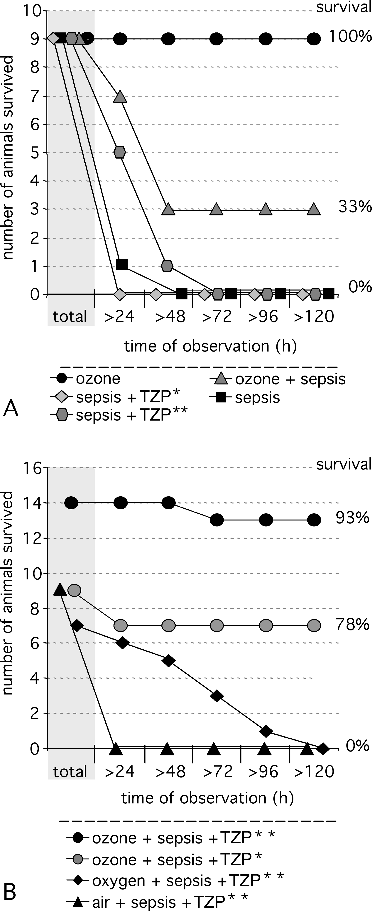
Fig. 2
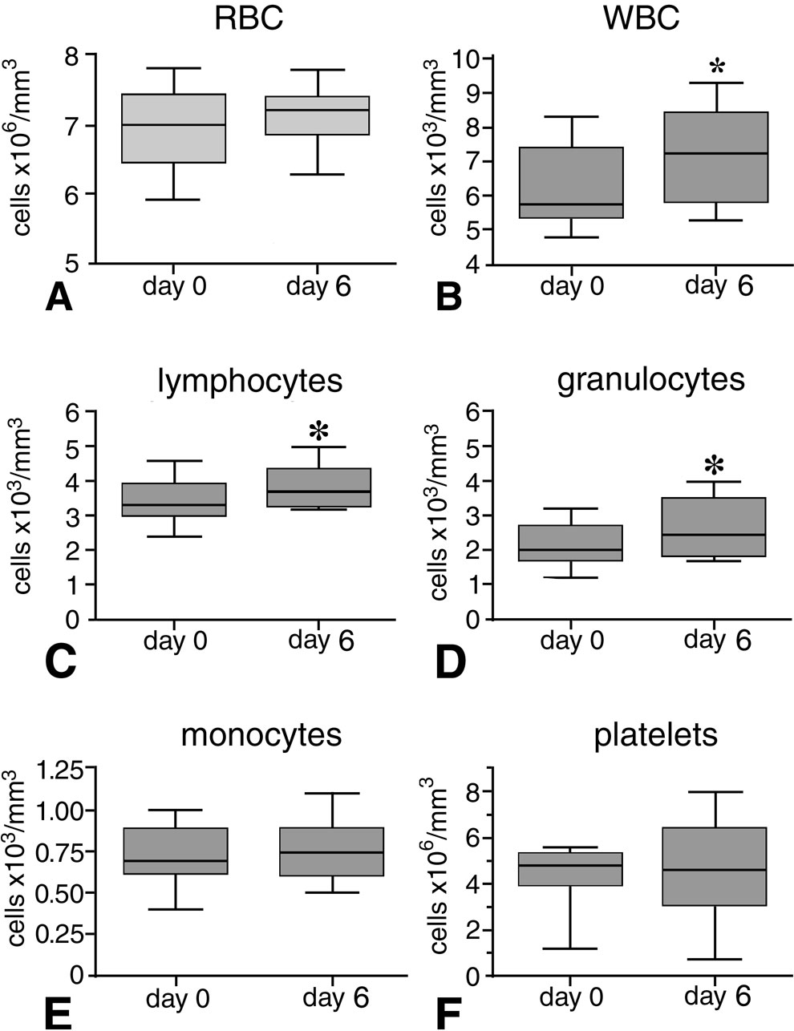
Fig. 3
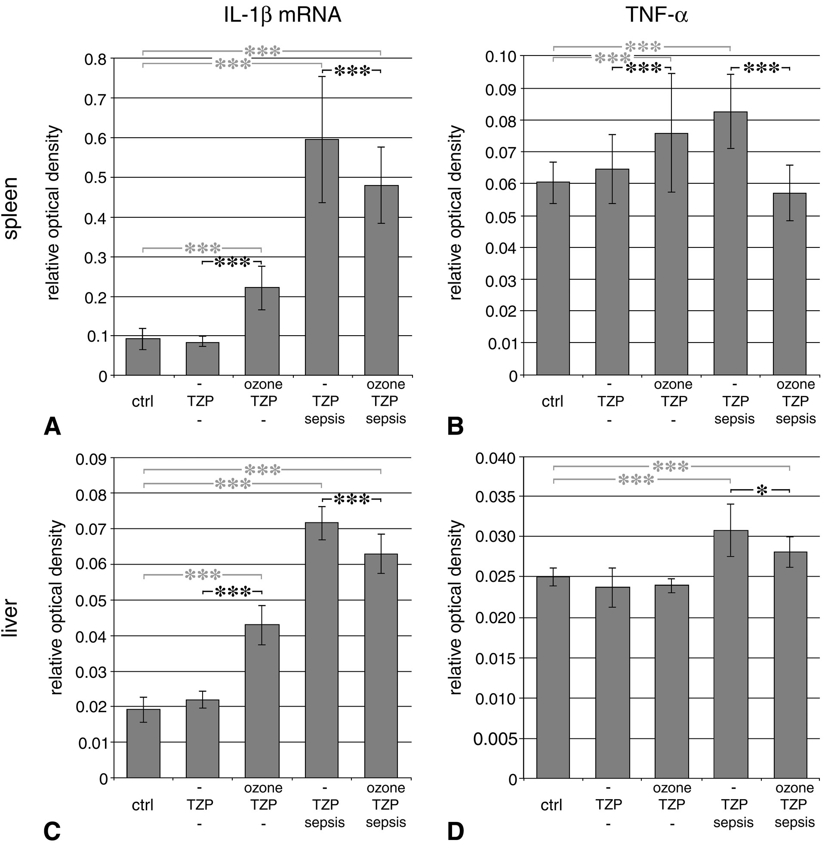
Fig. 4
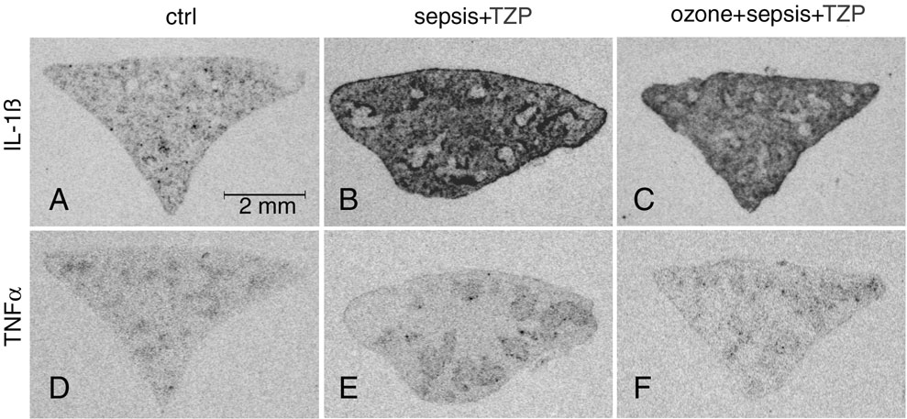

Fig. 5
